Residential Smoke Detector Recall Notice
You might have these recalled smoke detectors in your home – there is a risk they will not alert you in the event of a fire.
Brand name and model: Kidde Dual Sensor (photoelectric and ionization) smoke alarms – Models PI2010 and PI9010
Hazard: A yellow protective cap may have been left on one of smoke sensors during the manufacturing process, which could impede the alarm’s ability to detect smoke.
Remedy: Replace any smoke alarms that contain the yellow protective cap.
For more information or to register for a replacement smoke detector (if you have an affected one in your home), visit Kidde’s recall site https://kidde-smoke-alarm-recallusen.expertinquiry.com/

Carousel image for Compass:
Image: What the face of recalled Kidde smoke detectors looks like – only model with a pill-shaped design is affected
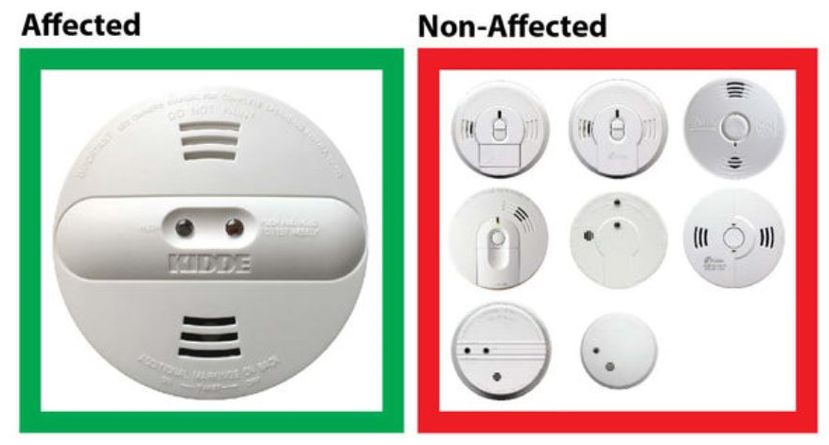
Image: Where to find model number on Kidde smoke detectors
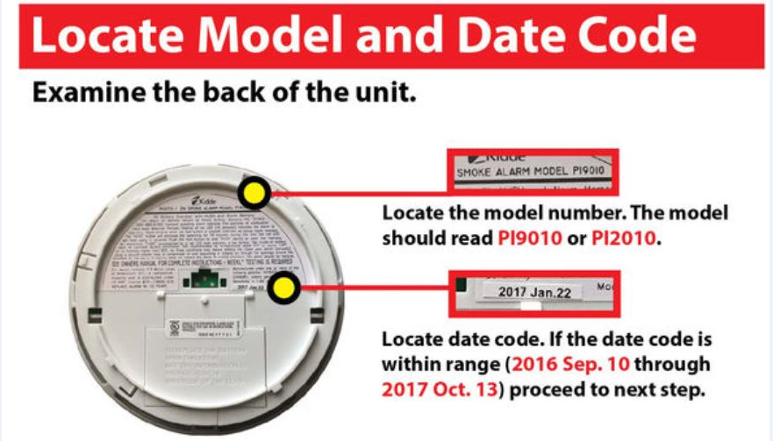
Image: How to check if your Kidde smoke detector is at risk – look for the yellow cap.
